Diameter of tree

maximum no. Of edges between any two nodes in a tree is called diameter of tree
Maximum distance b/n any two node.
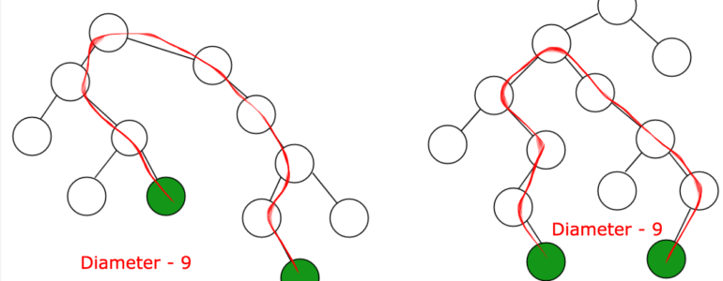
By brute force TC O(n*(V+E)
optimised way:
step1 with any node (as root) find maximum depth(distance) node.
Step2. Jo node ayegi us node ko root man k sabki depth nikal le wo diameter de dega.
TC O(V+E) +O(V+E)

i/p
13
1 2
1 3
1 13
2 5
3 4
5 6
5 7
5 8
8 12
4 9
4 10
10 11

o/p
diameter is 8

#include<bits/stdc++.h>
using namespace std;

const int N= 1e5+10;
vector<int> g[N];
int depth[N];

void dfs(int v, int par=-1){ // passing default value

for(int child: g[v]){
if(child==par) continue;
depth[child]=depth[v]+1;

dfs(child,v);
}

}

int main(){
int n;
cin>>n;
for( int i=0 ; i<n-1 ; i++){
int v1,v2;
cin>>v1>>v2;

g[v1].push_back(v2);
g[v2].push_back(v1);
}
dfs(1); // kisi ko leke kr skte hai.
// to find max depth node

int max_depth=-1;
int mx_d_node;
for(int i=1; i<=n ; ++i){
if(depth[i]>max_depth){
max_depth=depth[i];
mx_d_node=i;
}
depth[i]=0; // for reseting array
}
dfs(mx_d_node);
max_depth=-1; // reset
for(int i=1; i<=n ; ++i){
if(depth[i]>max_depth){
max_depth=depth[i];

}
}
cout<<"diameter is "<<max_depth;

}

